# C3- S5 PRACTICE

# SQUARE CONDITIONS REVERSE

Draw the shape that matches with the boolean expression

EXAMPLE :

(x > 2 and x < 5) and (y > 2 and y < 5)

SOLUTION :

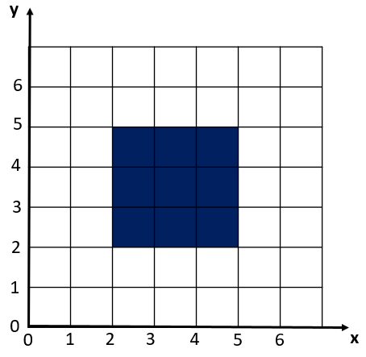

REVERSE-CONDITION 1 :

(x > 3 and x < 4) and (y > 1 and y < 2)

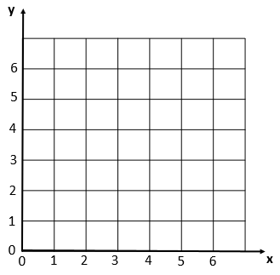

REVERSE-CONDITION 2 :

(x > 1 and x < 2) and (y < 4 and y > 2)



REVERSE-CONDITION 3 :

(x > 1 and x < 2) or (y < 4 and y > 2)

Same than pervious



REVERSE-CONDITION 4 :

((x>1 and x<2) and (y<4 and y>2)) or ((x>1 and x<2) and (y<4 and y>2))

Can be simplified.



REVERSE-CONDITION 5 :

(x>1 and x<6) and (y>1 and y<6) and x>3



REVERSE-CONDITION 9 :

(x>1 and x<6) and (y>1 and y<6) and not (x<3 and y<3)



REVERSE-CONDITION 10 :

(x>1 and x<5) and (y>1 and y<6) and not(x>2 and x<3 and y>2 and y<4)



REVERSE-CONDITION 11 :

x – y > 0



## CONDITION 8:

If (a>=1 or a>=4):(4>=1 or 4>=4)=True

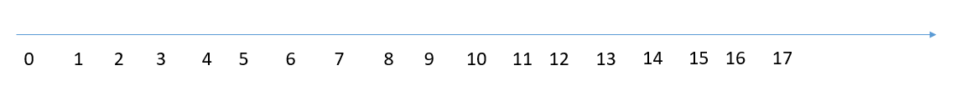

## CONDITION 9:

If (a>=3 and a>3): (4>=3 and 4>3) = true



## CONDITION 10:

If (a>=3 or a>3): (3>=3 and 3>3) = true



## CONDITION 11:

If (a>=4 and a<=4): (4>=4 and 4<=4) = true



## CONDITION 12:

If (a>4 or a<4): (5>4 or 5<4) = true



## CONDITION 13:

If (a>=4 or a<=4): (2>=4 or 2>=4) = true

